DHIS2 Relationship Tracing app

User Manual (v 0.9.0)

* When you start the application, if there are no visualisations present in the app, it will prompt you to create a new visualisation.

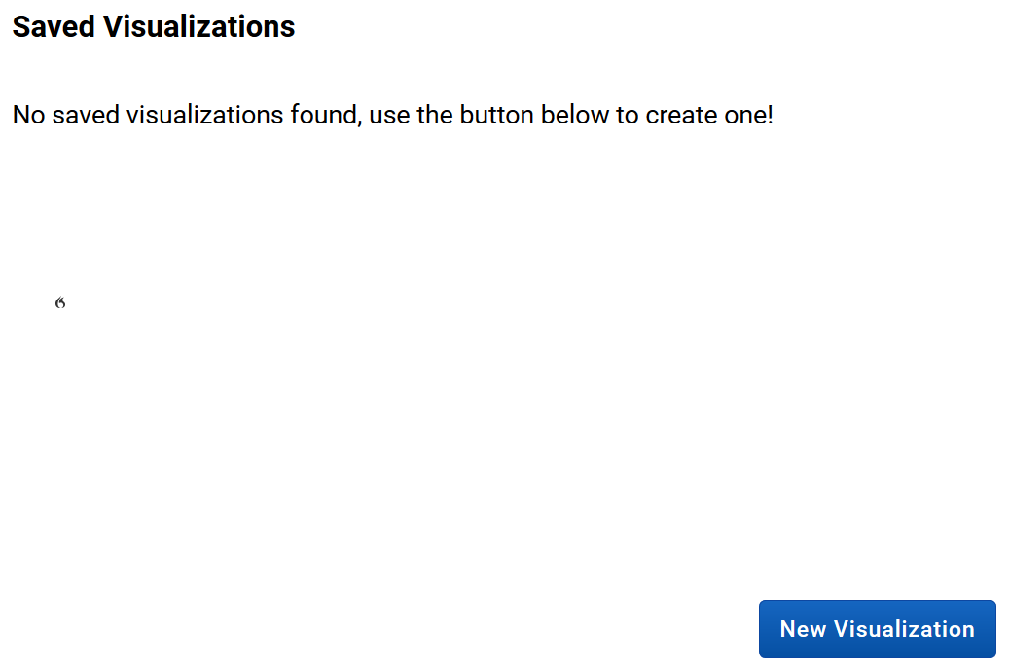

* First step in the configuration is to provide the visualisation a name.

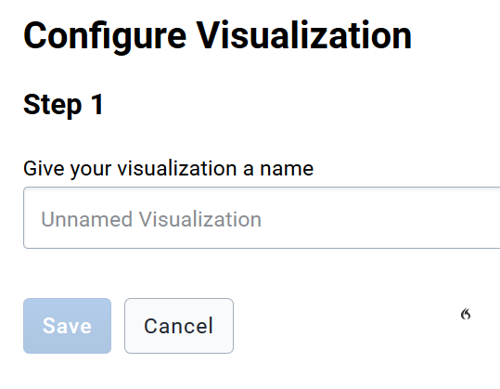

* Step 2 will request you to select the relationships to be included in the visualisation. You could include a single relationship or more.

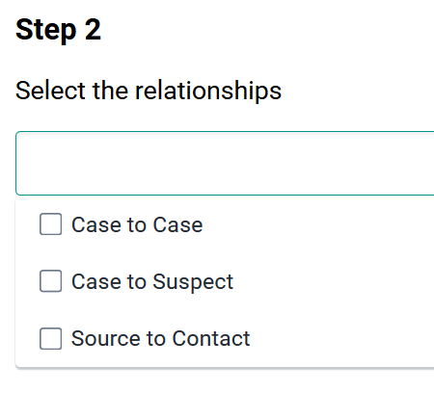

* Next step is to define that tracked entity templates. In here, we will define the name that should appear for the Tracked Entity Instance (TEI) in the graph, the colour of the TEI and the program the TEI is registered to. In addition, this step will let us configure the label that should appear next to a TEI in the visualisation. We will at minimum need to add two templates (TEIs) in the following configuration to visualise simple contact map involving two entities (eg: case to contact). Click on ‘Add Template’ to configure the first tracked entity in the visualization.

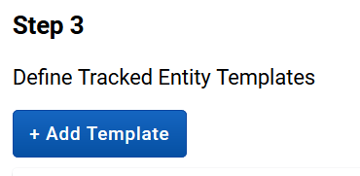

* You will be able to see the available configurations under this step as follows.

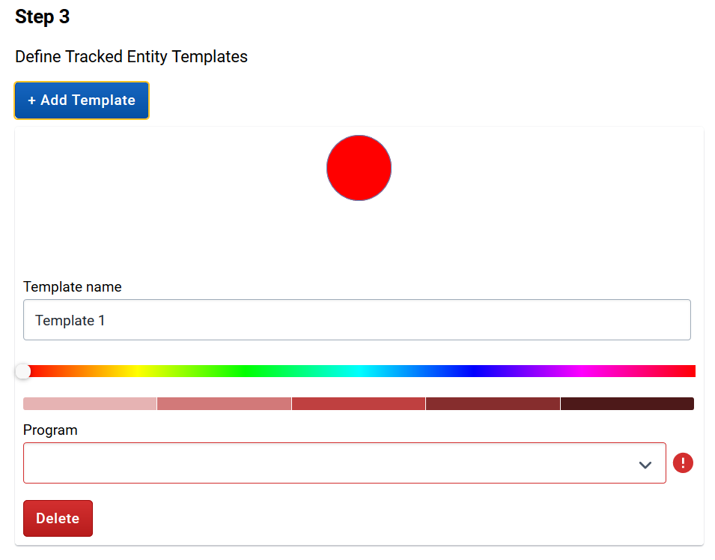

* You can start by providing the template a name. Generally this could be the name of the TEI that should appear in the visualisation.

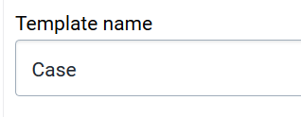

Next, you can select a colour for the TEI node in the visualisation by selecting a colour from the colour slider.

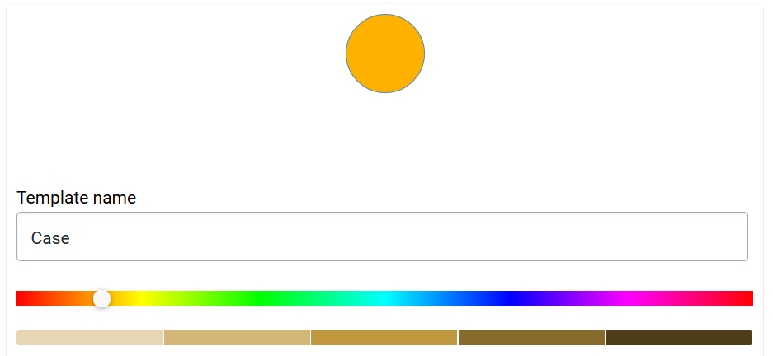

* Select the program to which the TEI belongs to from the drop-down menu.

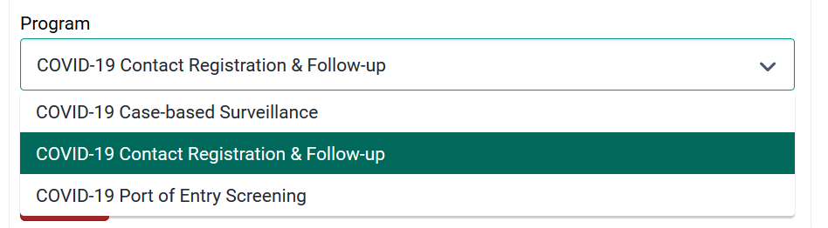

* Clicking on ‘Show Node Label’ will allow you to select the attribute of the TEI that should appear next to the TEI as the label in the visualisation.

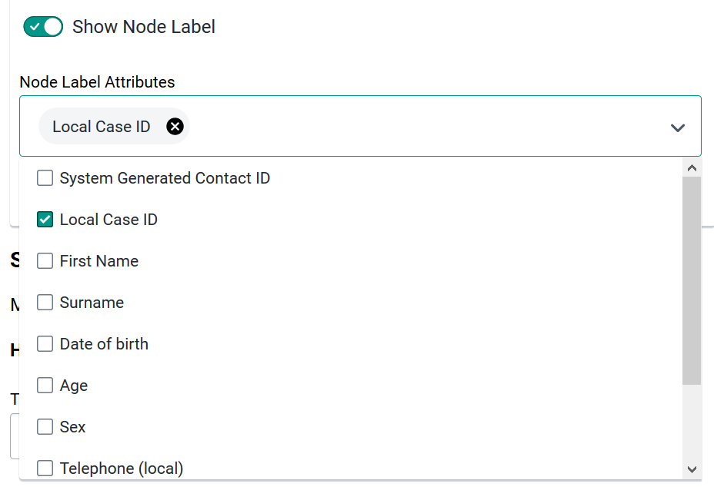

* We need to follow the above steps of adding a new template again to configure the second TEI in the visualisation. Once configured, you will be able to see the configuration screen as below.

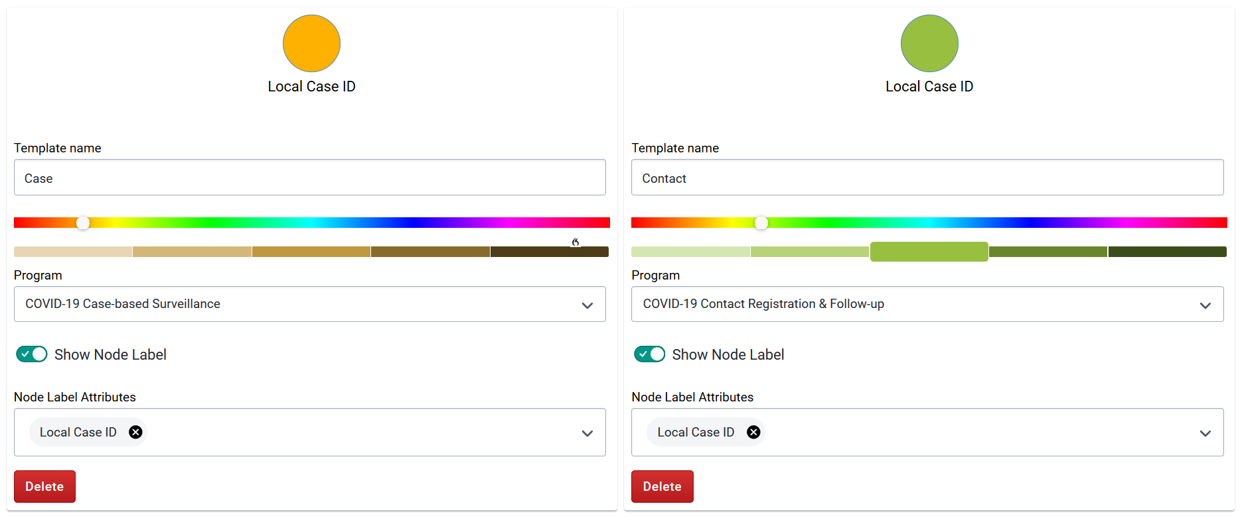

* In the above screenshot, we have configured a TEI from COVID-19 Case-based Surveillance program (Case) to be mapped to a TEI from COVID-19 Contact Registration & Follow-up (Contact).
* Step 4 allows us to map templates to relationship. Here we define the originating (from) TEI and the destination (to) TEI per relationship we have configured under Step 2.

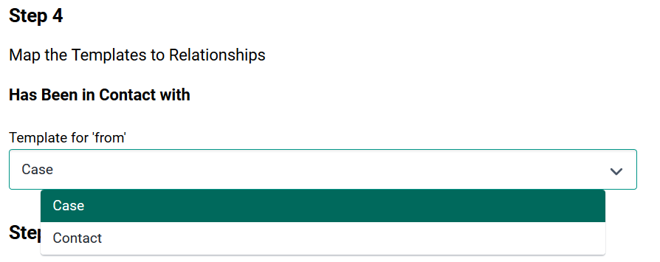

* In the above screen we are defining the ‘from’ template for the relationship ‘Has Been in Contact with’. We need to choose between the templates ‘Case’ and ‘Contact’ which we have defined under Step 3.
* We follow the same step for the configuration of the ‘Contact’ template in the relationship. Once done, you’ll see a similar screen as below.

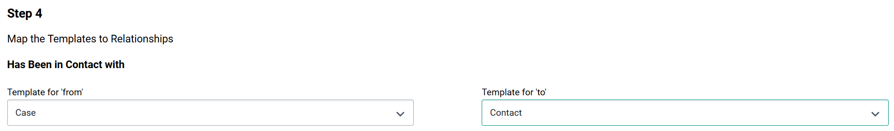

* The final step in the configuration allows us to set up following two features.

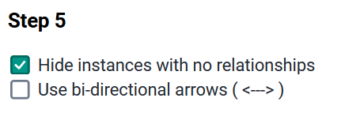

* + Hide instance with no relationships: this will hide any TEI which does not have a relationship to another TEI. The decision to enable this feature depends on the context that you are applying to. Eg: sometimes it may be crucial to visualize TEIs without any relationships in a contact map to highlight the significance of that isolated entity. In another context, if we have too many TEIs without relationships configured, it may require to hide the ones without relationships to make the visualisation clean and clear.
  + Use bi-directional arrows: this allows the visualisation to show the bi-directional relationship as opposed to uni-directional relationship which is setup by default.
* Once the above steps are configured, click on ‘Save’ button.
* Prior to loading the visualization, it is required to filter the TEIs based on enrolment date to limit the nodes that appear in the visualization. Select the start and end dates and click on ‘Update’.

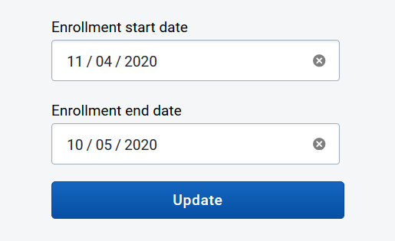

* You will be able to see the visualisation like below.

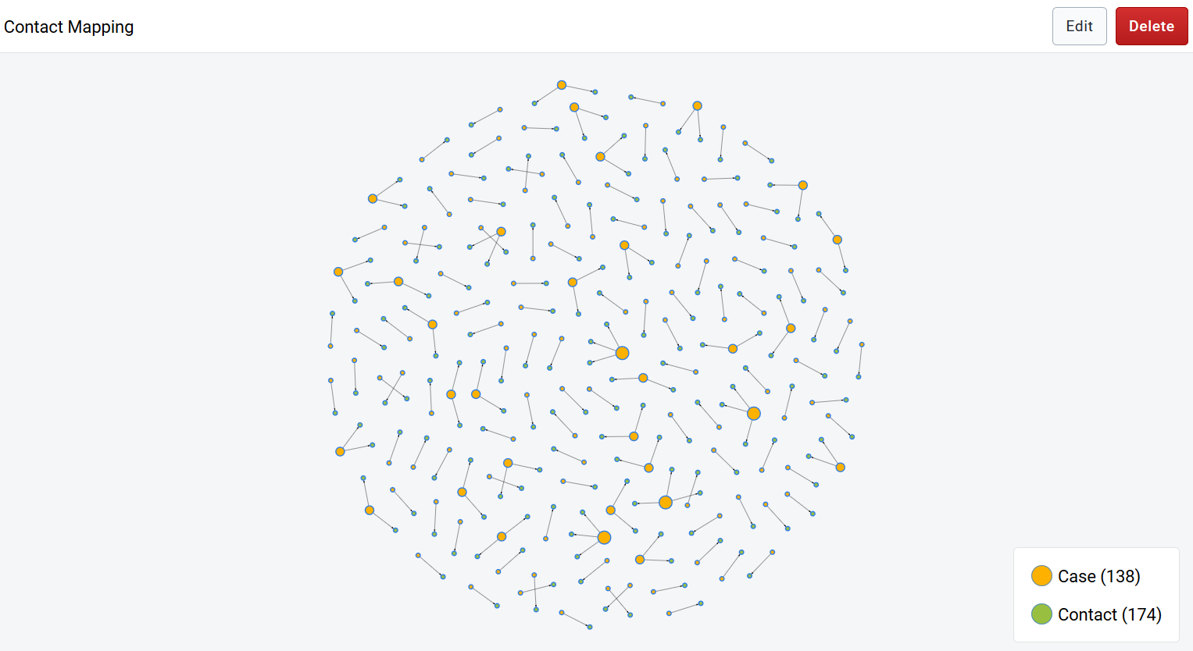

* You can zoom in to focus on individual roles in the visualisation if the map contains too many notes.

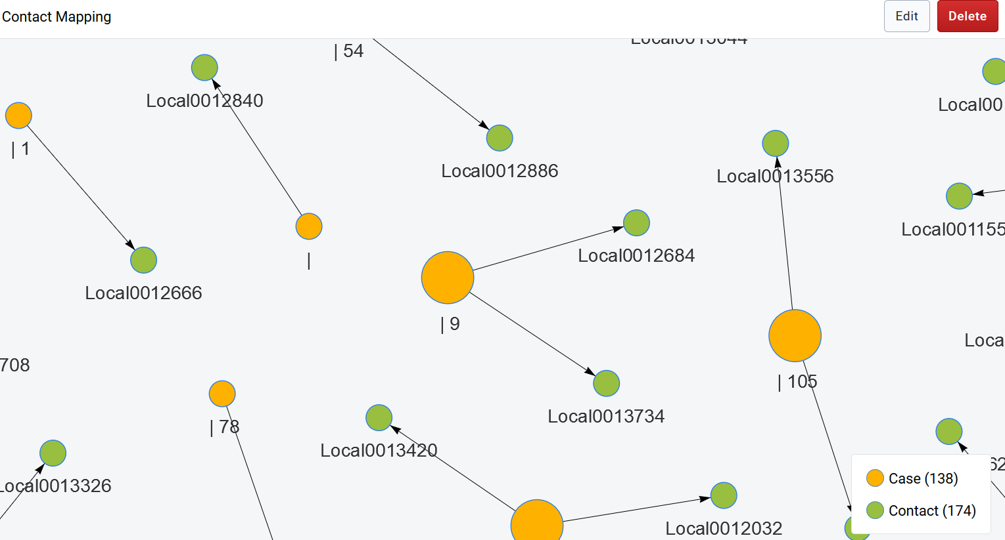

* Once zoomed in you’ll be able to see the nodes (TEIs) colour-coded as defined in the configuration page, the labels and their relationships as mentioned in the above screenshot.
* Bottom right side of the screen mentions the number of TEIs in the visualization (eg: Cases and Contacts).
* If you click on a TEI it will pop up window which includes a summary of the TEIs based on attributes captured in the system.

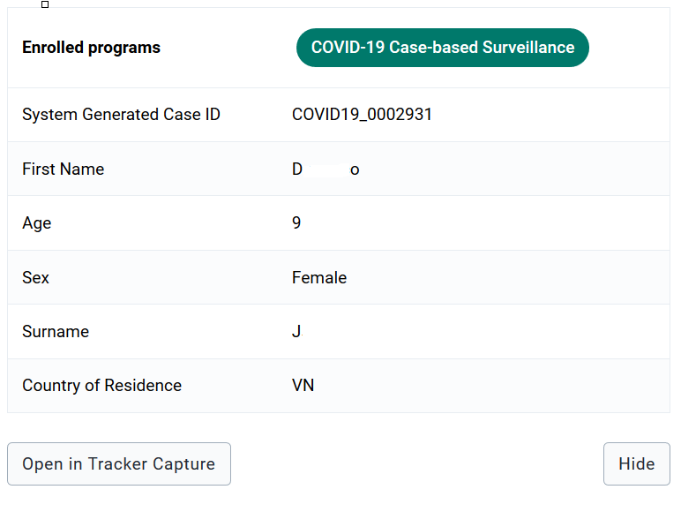

* If you click on ‘Open in Tracker Capture’, it will take you to the TEI dashboard of the particular TEI in the tracker capture app.

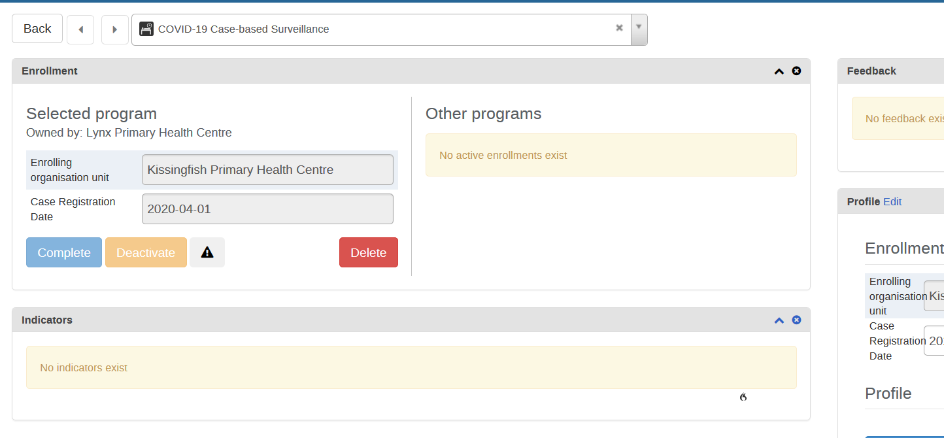

* The left side of the screen allows you to filter the nodes involved in the visualization based on time of enrolment

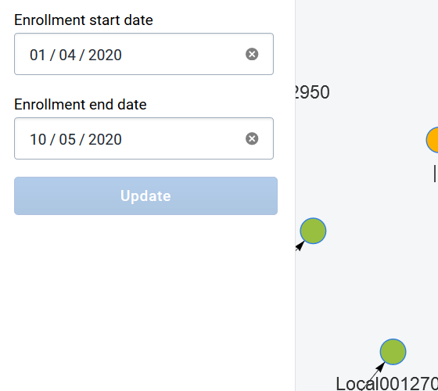

* in case, the visualisation is likely to contain too many TEIs, it will prompt you an error message as below. You may need to narrow the time window to load visualization properly.

